Oifig Faisnéise  Áras Talmhaíochta  Sráid Chill Dara  Baile Átha Cliath 2  Tel: (01) 607 2190  Fax: (01) 662 1165 | 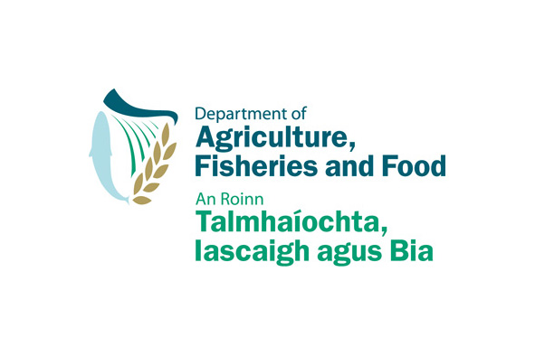 | Press/Information Office  Agriculture House  Kildare Street  Dublin 2  E-mail: info@agriculture.gov.ie  Website: www.agriculture.gov.ie
PRESS RELEASE
108/08

MINISTER PUBLISHES CONSULTATION PAPER ON

DRAFT ANIMAL HEALTH & WELFARE BILL

The Minister for Agriculture, Fisheries and Food, Mr Brendan Smith TD, today published a consultation paper on a new draft Animal Health & Welfare Bill.

Minister Smith described the consultation process as “offering stakeholders and other interested parties a unique opportunity to contribute to the preparation of a modern and comprehensive Bill that will be fit-for-purpose in the 21st century.”

Mr Smith said that considerable work had already been done within his Department in identifying outdated legislation that now needed to be repealed as well as other legislative provisions that ought to be updated and consolidated into a single, accessible and convenient statute.

The Minister said that the new legislation would be “of great value to those involved with animals, whether they are farmers or pet owners, veterinary practitioners or others with an interest or involvement in the health and welfare of animals.”

Minister Smith said that the publication of this paper was a significant step in the delivery of commitments in the Programme for Government to introduce a new Animal Health Bill, to consolidate and amend previous legislation to reflect the changed disease status of our nation’s animals, as well as a comprehensive Animal Welfare Bill, updating existing legislation, to ensure that the welfare of animals is properly protected and that the penalties for offenders are increased significantly.

Mr Smith said that he hoped that all those interested would avail of the six-week period to make their submissions and assured all those making submissions that full account will be taken of them in finalising the drafting of the Bill later in the year. In addition, the Minister confirmed that officials of his Department would be consulting with some or all of those who make submissions to provide a further opportunity to pursue some of the suggestions or proposals made.

28 May, 2008
ENDS

